Game : Capture the Flag
Core Concept
A team-based competitive game where players solve cybersecurity challenges (“flags”) faster than the opposing team.
Each match is short (5–15 minutes), high-energy, and focused on quick problem-solving rather than deep hacking skills.
Everything is designed to be safe, age-appropriate, and completely sandboxed.

Game Structure & Flow
Lobby & Team Setup
- 2–6 players per match
- Auto-matchmaking or “classroom mode” where teachers can create private rooms
- Players join Red Team or Blue Team
- Each team chooses roles (optional for complexity):
  - Analyst – best at phishing identification & logs
  - Cryptographer – cipher puzzles
  - Engineer – system vulnerabilities & patching
  - Wildcard – mixed tasks
Roles provide hint bonuses, not restrictions, so students can try any challenge.

Match Rounds
A match consists of 3–5 rounds.
Each round contains multiple puzzle stations, each holding a “flag.”
Teams choose which stations to attack, introducing strategy:
- “Do we go for the easy flags quickly?”
- “Do we attempt the hard but high-value flag?”
- “Do we split up or work together?”
Each flag has a point value:
Easy (10 pts)
- Mock emails
- Chat messages
- Fake login pages
- Social media posts
Medium (20 pts)
Hard (40 pts)
Basic Sketch
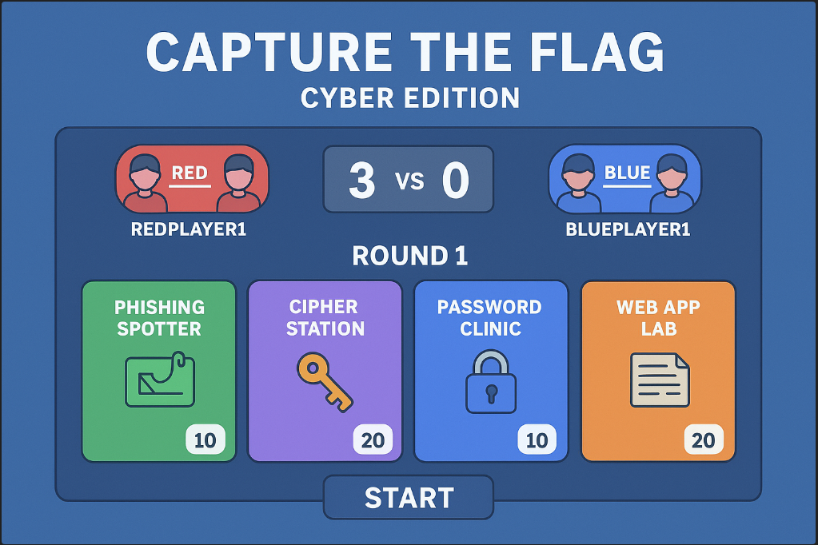
Best Features
The game includes four challenge types that directly map to UK computing curriculum strands:
- Phishing Spotter → Online safety & social engineering awareness
- Cipher Station → Cryptography & data representation
- Password Clinic → Cyber hygiene & authentication
- Web App Lab → Networks, vulnerabilities, and system security

Relate to existing games
Kahoot! (Educational, Quiz-Based)
Similarities:
- Fast-paced questions and instant feedback
- Competitive team feels
- Points that reward accuracy and speed
Differences / Improvements:
- Your game has interactive puzzles, not just multiple-choice
- Stronger focus on cybersecurity principles
- Players choose which challenge to attempt → strategic element

